Lab 3: Using EF Core CLI to Create and Apply Migrations
This guide walks through Lab 3 of your EF Core hands-on exercises for a Retail Inventory System. The goal is to create and apply migrations using EF Core CLI with a SQLite database.
Scenario
You are building a retail inventory database. You’ll use EF Core CLI to:
Create a database schema from your models
Apply the schema to generate the database
Verify that the data is persisted
Final Folder Structure
RetailInventory/
├── AppDbContext.cs
├── Models.cs
├── Migrations/
├── Program.cs
├── RetailDb.db
├── RetailInventory.csproj
Step 1: Create the Project
Open VS Code terminal and run the following:
dotnet new console -n RetailInventory
cd RetailInventory
Step 2: Install EF Core Packages
Run these commands to add EF Core packages for SQLite:
dotnet add package Microsoft.EntityFrameworkCore.Sqlite
dotnet add package Microsoft.EntityFrameworkCore.Design
Step 3: Install EF Core CLI
If not already installed, install the EF Core command line interface globally:
dotnet tool install --global dotnet-ef
Step 4: Add Models.cs
Create a file named Models.cs and paste the following code:
using System.Collections.Generic;

public class Category
{
public int Id { get; set; }
public string Name { get; set; }
public List<Product> Products { get; set; }
}

public class Product
{
public int Id { get; set; }
public string Name { get; set; }
public decimal Price { get; set; }
public int CategoryId { get; set; }
public Category Category { get; set; }
}
Step 5: Add AppDbContext.cs
Create a file named AppDbContext.cs and paste the following code:
using Microsoft.EntityFrameworkCore;

public class AppDbContext : DbContext
{
public DbSet<Product> Products { get; set; }
public DbSet<Category> Categories { get; set; }

protected override void OnConfiguring(DbContextOptionsBuilder optionsBuilder)
{
optionsBuilder.UseSqlite("Data Source=RetailDb.db");
}
}
Step 6: Add Program.cs
Replace the existing Program.cs content with:
using System;
using System.Linq;

class Program
{
static void Main()
{
using (var context = new AppDbContext())
{
context.Database.EnsureCreated();

if (!context.Categories.Any())
{
var electronics = new Category { Name = "Electronics" };
var laptop = new Product { Name = "Laptop", Price = 799.99m, Category = electronics };

context.Categories.Add(electronics);
context.Products.Add(laptop);
context.SaveChanges();

Console.WriteLine("Database created and sample data added.");
}
else
{
Console.WriteLine("Database already has data.");
}
}
}
}
Step 7: Create the Migration
Run this in the terminal to generate the initial migration code:
dotnet ef migrations add InitialCreate
This creates a new Migrations/ folder containing the migration definition files.
Step 8: Apply the Migration
Run this command to create the SQLite database and apply the schema:
dotnet ef database update
This will generate a file named RetailDb.db with your database tables.
Step 9: Run the Application
Execute the program to test that the data is added correctly:
dotnet run
Expected Output
On first run, you should see:
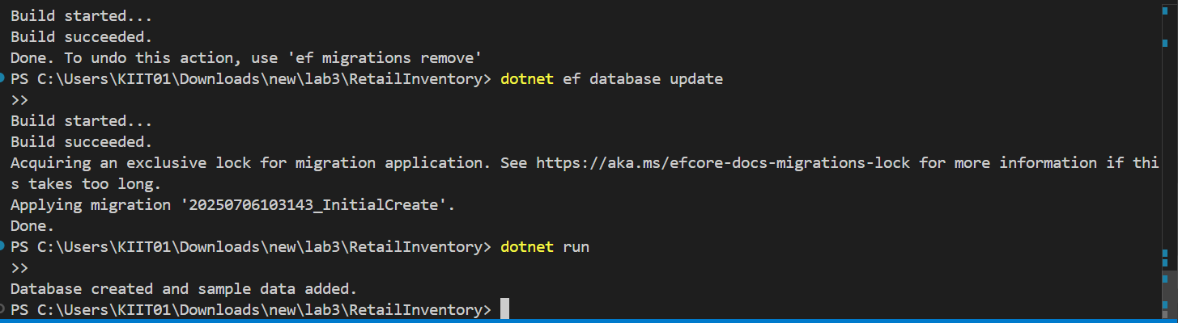On subsequent runs, it will show:
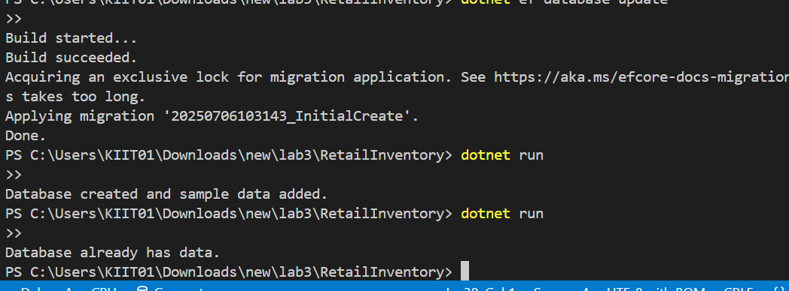

Verify the Data
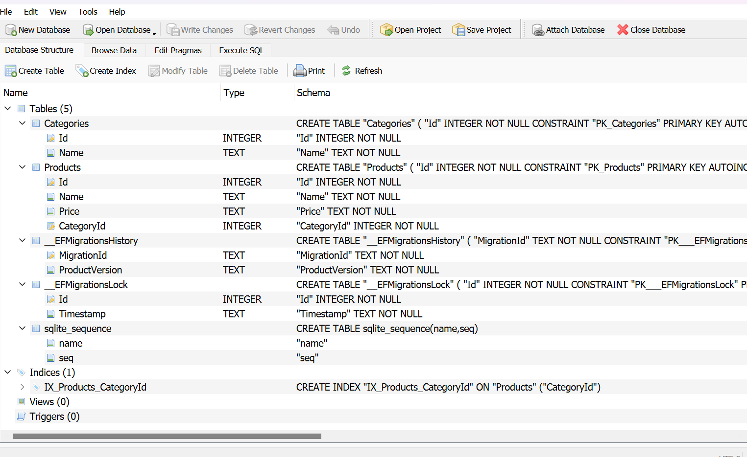

Summary of All Commands
dotnet new console -n RetailInventory
cd RetailInventory

dotnet add package Microsoft.EntityFrameworkCore.Sqlite
dotnet add package Microsoft.EntityFrameworkCore.Design

dotnet tool install --global dotnet-ef

dotnet ef migrations add InitialCreate
dotnet ef database update
dotnet run

